**Year 11 Human Biological Science**

**Respiratory and Circulatory Systems**

Name: ____________________________________________ /61

Multiple Choice Answer Sheet

1. A B C D 11. A B C D

2. A B C D 12. A B C D

3. A B C D 13. A B C D

4. A B C D 14. A B C D

5. A B C D 15. A B C D

6. A B C D 16. A B C D

7. A B C D 17. A B C D

8. A B C D 18. A B C D

9. A B C D 19. A B C D

10. A B C D 20. A B C D

21. A B C D

**Year 11 Human Biological Science**

**Respiratory and Circulatory Systems**

Name: ____________________________________________

**PART A: Multiple Choice (21 marks)**

1. Which of the following best described blood carried in the pulmonary vein.

a) It is deoxygenated and will enter the left atrium

b) It is deoxygenated and will enter the heart after passing the semi lunar valve

c) It is oxygenated and will enter the left atrium

d) It is oxygenated and will enter the heart after passing the semi lunar valve

2. What is the role of the chordinae tendonae?

a) They act as a portion of the skeleton of the heart, strengthening heart walls.

b) They keep the semilunar valves in position.

c) They keep the atrio-ventricular valves from opening in the wrong direction.

d) They contract to move blood through the heart.

3. Capillaries :

a) are one cell thick and allow nutrients to move into the cells.

b) are one cell thick which allows carbon dioxide to move from the plasma into muscle cells.

c) contain smooth muscle and can undergo vasoconstriction.

d) carry deoxygenated blood to the body tissues.

4. The majority of the oxygen in human blood is:

a) dissolved in the plasma.

b) chemically converted to water.

c) combined with haemoglobin.

d) combined with carbon dioxide to form bicarbonate ions.

5. Which of the following is **incorrect** about the space between the pleural membranes:

a) It contains pleural fluid

b) It holds the lungs against the inside of the chest wall

c) It helps warm the air in the lungs

d) It allows the lungs to slide along the chest wall when breathing

6. The intercostal muscles contract during which process?

a) Exhalation

b) Inhalation

c) Respiration

d) Metabolism

7. Which of the following is correct about a person with Type A blood?

a) They have the A antigen and anti B antibodies

b) They have the A antigen and anti B and anti AB antibodies

c) They have A antibodies and can produce B antigens

d) They have A antibodies and can produce AB and B antigens

8. Complete the sentence with the correct terms:

Blood from the arms returns to the heart via the _____1_____ and enters the ____2____.

|  |  |  |
| --- | --- | --- |
|  | 1 | 2 |
| a) | Vena cava | Right atrium |
| b) | Vena cava | Left atrium |
| c) | Pulmonary vein | Right atrium |
| d) | Femoral vein | Left atrium |

9.

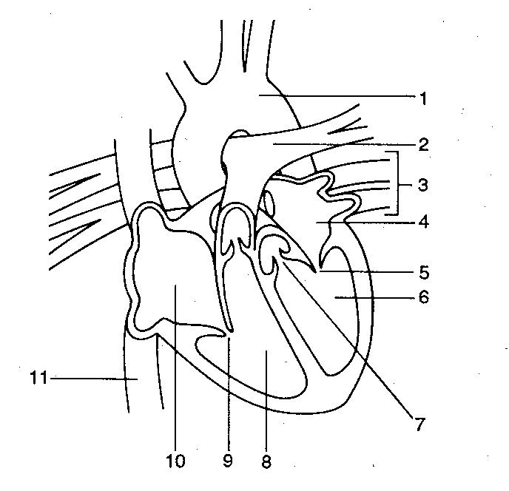

Using the diagram above, which of the following label the parts of the heart correctly:

|  |  |  |  |
| --- | --- | --- | --- |
| A | 7 = semilunar valve | 9 = atrioventricular valve | 3 = pulmonary artery |
| B | 8 = left ventricle | 1 = aorta | 5 = semilunar valve |
| C | 4 = left atria | 3 = pulmonary vein | 11 = superior vena cava |
| D | 11 = inferior vena cava | 2 = pulmonary artery | 1 = aorta |

10. The major driving force that moves blood in the veins is

a) active transport.

b) passive transport.

c) the closing of one-way valves.

d) skeletal muscle contractions.

11. Cardiac output can be reduced by

a) increasing heart rate.

b) decreasing stoke volume.

c) increasing the strength of ventricular contraction.

d) decreasing the concentration of oxygen in the blood.

The next THREE questions refer to the following diagram:

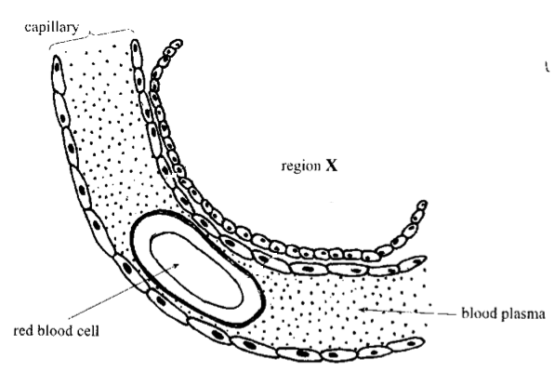

12. The region labelled X represents part of the

a) glomerulus.

b) alveolus.

c) villus.

d) cell.

13. The feature labelled red blood cell:

a) is called a Erythrocyte and carries the majority of the Carbondioxide in the blood in the form of carbaminohaemoglobin

b) is called a Erythrocyte and carries the majority of the Oxygen in the blood in the form of oxyhaemoglobin

c) is called a Thrombocyte and carries the majority of the Carbondioxide in the blood in the form of carbaminohaemoglobin

d) is called a Thrombocyte and carries the majority of the Oxygen in the blood in the form of oxyhaemoglobin

14. The concentration of carbon dioxide gas in the capillary is:

a) high and will move into region X.

b) low and will move into the blood plasma.

c) high and will move onto the red blood cell.

d) low and will move from the red blood cell to region X.

15. Which of the following is INCORRECT about blood clotting?

a) Platelets stick to any damaged surfaces of blood vessels, attracting more platelets

b) During clot retraction plasma is squeezed out of the clot

c) Fibrin are threads of insoluble proteins

d) Stuck platelets release vasoconstrictors

16. During the last stage of the cardiac cycle, which of the following events is occurring?

a) Atria relax while the ventricles contract; atrioventricular valves are closed while the semilunar valves are open.

b) Atria contract while the ventricles relax; atrioventricular valves are open while the semilunar valves are closed.

c) Atria and ventricles are relaxed; atrioventricular valves are open while the semilunar valves are closed.

d) Blood moves from the right ventricle into the aorta while blood moves from the left ventricle to the pulmonary artery.

17. The highest carbon dioxide concentrations will be found in blood

a) leaving the muscles.

b) entering the muscles.

c) leaving the lungs.

d) entering the lungs.

18. Asthma

a) is a result of widening of the bronchioles.

b) is a result of the contraction of smooth muscle in the bronchioles

c) is always caused by allergies.

d) is a result of lack of mucous in the airways.

19. A person with a higher metabolic rate would

a) have a higher breathing rate.

b) have a lower cardiac resting rate.

c) eat less.

d) produce less energy.

20. Cartilage rings:

a) form complete circles in the trachea.

b) prevent the oesophagus from collapsing.

c) maintain an open airway.

d) are found in the bronchioles.

21. Someone with Rh antigens, anti-B antibodies and A antigens has blood type:

a) O-

b) A+

c) AB+

d) either B- or A-

**PART B: Short Answers (40 marks)**

[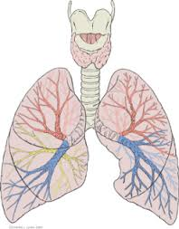](http://www.google.com.au/url?sa=i&rct=j&q=respiratory+system+diagram&source=images&cd=&cad=rja&uact=8&docid=34EVfcOo_mj2PM&tbnid=ayYPK4aqItfBcM:&ved=0CAUQjRw&url=http://www.medical-exam-essentials.com/human-respiratory-system.html&ei=nNQ8U8WjEsSllQXFr4DgCQ&psig=AFQjCNETRPXr3Aji6cYGSqeh7OFIPmIdmw&ust=1396581848908616)1. a) On the diagram above locate and name the respiratory surfaces where gas exchange occurs. (1 mark)

b) Explain two ways in which moisture is maintained on these surfaces (2 marks)

_______________________________________________________________________________________

_______________________________________________________________________________________

_______________________________________________________________________________________

_______________________________________________________________________________________

2. a) Explain the ways in which carbon dioxide is transported in the blood. Include the amount of carbon dioxide transported via each method. (3 marks)

_______________________________________________________________________________________

_______________________________________________________________________________________

_______________________________________________________________________________________

_______________________________________________________________________________________

_______________________________________________________________________________________

b) Explain how carbon dioxide moves from the blood, into the lungs and out of the body. (2 marks)

_______________________________________________________________________________________

_______________________________________________________________________________________

_______________________________________________________________________________________

3. Expired air and inspired air differ in composition. The following table gives an approximate comparison.

|  |  |  |
| --- | --- | --- |
|  | INSPIRED AIR  (Total volume) | EXPIRED AIR  (Total volume) |
| Oxygen | 21% | 17% |
| Carbon Dioxide | 0.04% | 4% |
| Nitrogen and inert gases | 78% | 78% |
| Water vapour | Varies | Saturated |
| Temperature | Atmospheric | Body (37o C) |

Explain the differences or the lack of difference between any two of the inspired and expired values of the substances shown in the table. (Eg choose Water vapour and CO2 or O2 and Temperature) (4 marks)

_______________________________________________________________________________________

_______________________________________________________________________________________

_______________________________________________________________________________________

_______________________________________________________________________________________

_______________________________________________________________________________________

_______________________________________________________________________________________

_______________________________________________________________________________________

_______________________________________________________________________________________

_______________________________________________________________________________________

_______________________________________________________________________________________

4a. What is the name of the structure shown below? What is its function? (3 marks)

_______________________________________________________________________________________

_______________________________________________________________________________________

_______________________________________________________________________________________

_______________________________________________________________________________________

_______________________________________________________________________________________

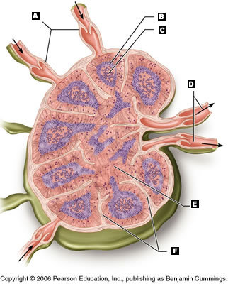

4b. What would be entering at A? (1 mark)

_______________________________________________________________________________________

4c. What is the destination of the substance leaving at D? (1 mark)

_______________________________________________________________________________________

5.

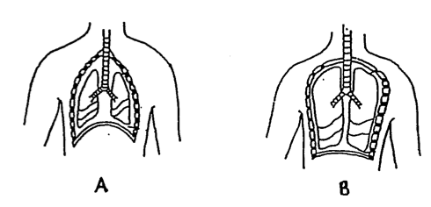

Which diagram indicates a person that is inhaling? Explain your reasoning. (3 marks)

_______________________________________________________________________________________

_______________________________________________________________________________________

_______________________________________________________________________________________

_______________________________________________________________________________________

6. Macrophages are found in the lymph system. What is their function and how do they carry out this function? You may use a diagram to help your explanation. (3 marks)

7. The diagram below shows a capillary and the surrounding cells it supplies

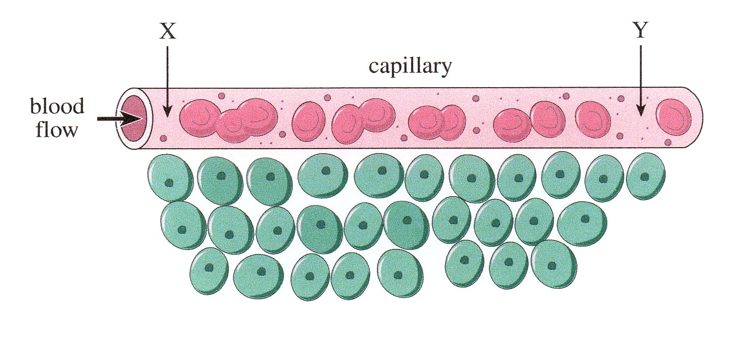

CIRCLE the CORRECT term in each of the following statements.

As blood flows through the capillary from Point X to Point Y: (6 marks)

i) the amount of glucose in the blood increases/decreases.

ii) the amount of oxygen in the blood increases/decreases.

iii) the amount of carbon dioxide in the blood increases/decreases.

iv) the amount of oxyhaemoglobin in the blood increases/decreases.

v) the amount of carbaminohaemoglobin in the blood increases/decreases.

vi) the pressure in the vessel increases/decreases.

8. During a heart dissection, you notice that ‘one side’ of the heart is much thicker that the other side (see photo below). Your group members say this is because the thick side pumps more blood as the heart is a double pump.

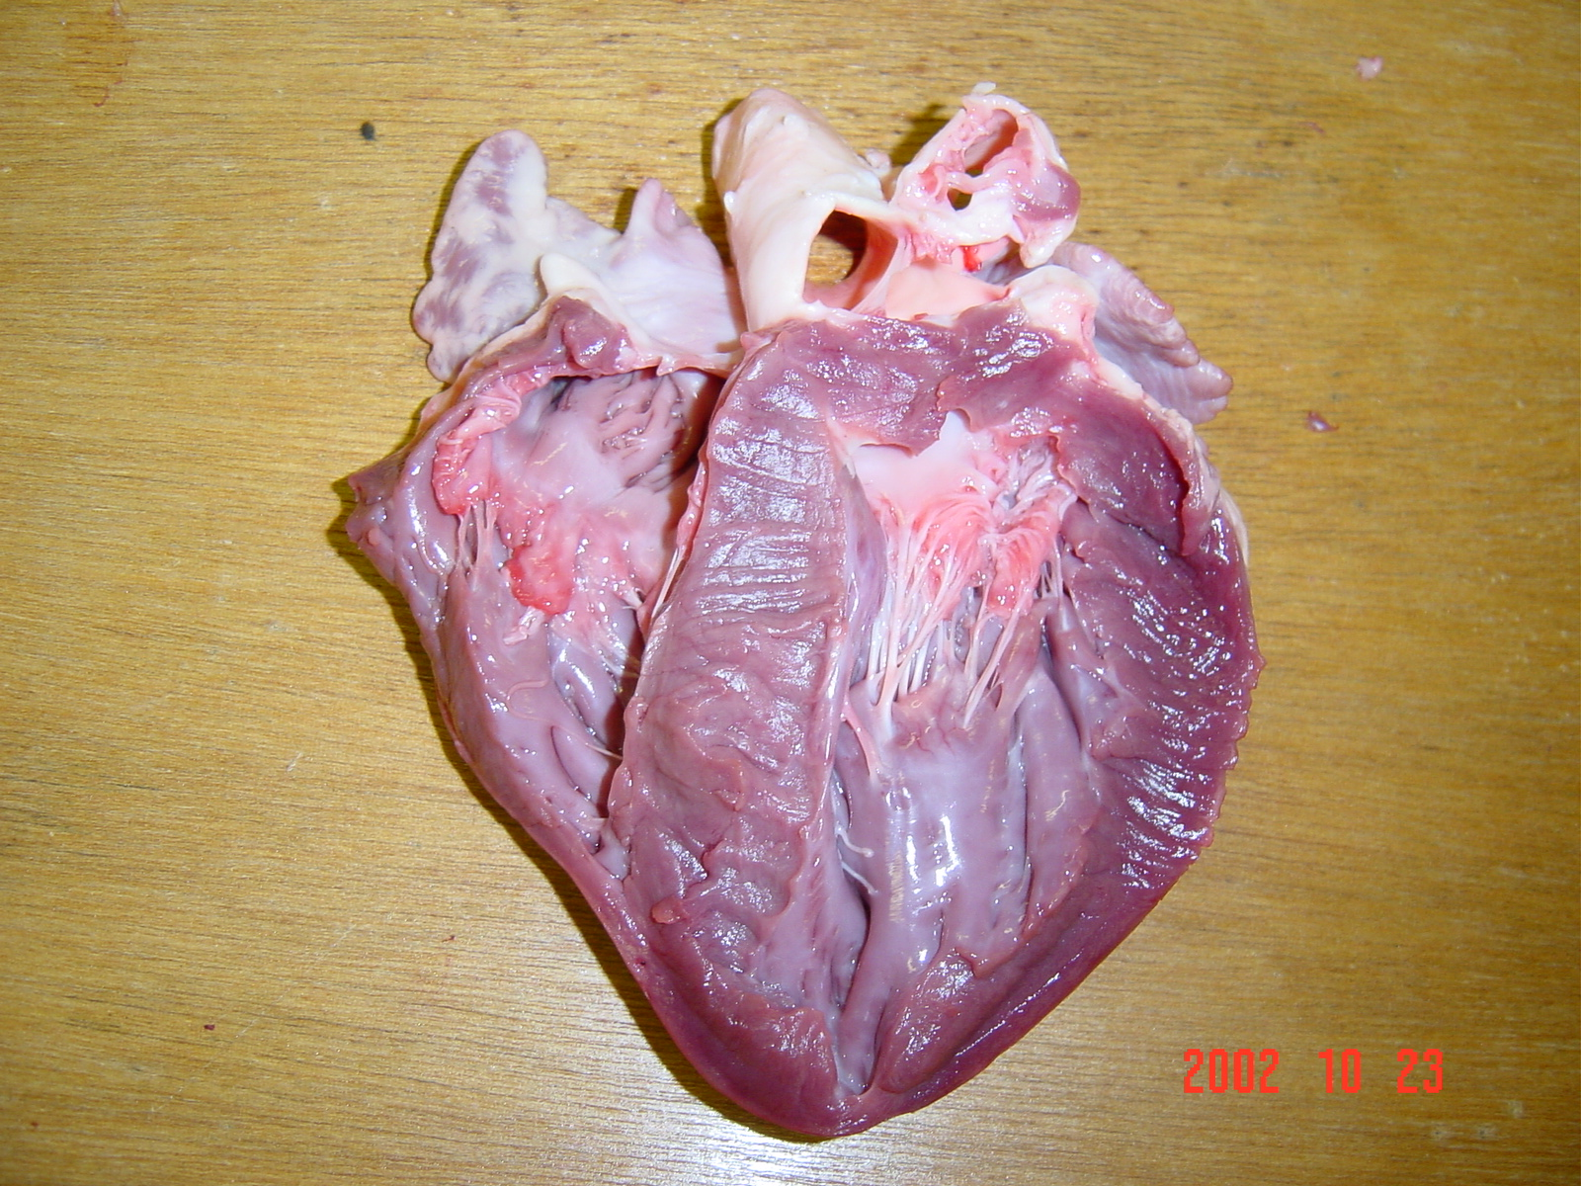

Thicker

Side.

a) What is the ‘thick part’ of the heart structure that is being examined? (1 mark)

_______________________________________________________________________________________

b) Are your fellow group members correct for stating that ‘*this side is thicker as it pumps more blood’*?

Explain. (2 marks)

_______________________________________________________________________________________

_______________________________________________________________________________________

_______________________________________________________________________________________

7. The graph below shows the bpm of a trained athlete before during and after exercise (bottom line) and an untrained person (top line) before during and after exercise

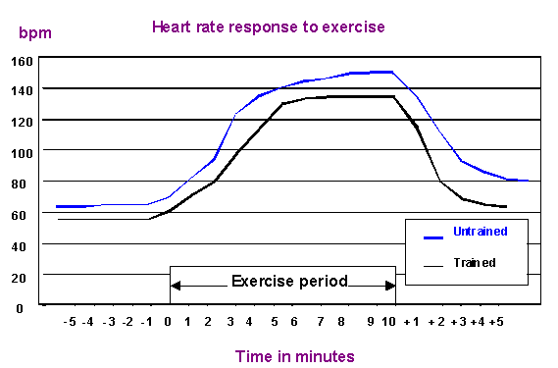

a) What is bpm? (1 mark)

_______________________________________________________________________________________

b) Trained athletes have a lower bpm before during and after exercise. Does this mean they need to pump less blood than someone who is untrained? Explain how this is possible. (2 marks)

____________________________________________________________________________________________________________________________________________________________________________________________________________________________________________________________________________________________________________________________________________________________

c) In which part of the graph is there the biggest difference between the trained and untrained athlete? Why is this so?

(2 marks)

_____________________________________________________________________________________________________________________________________________________________________________________________________________________________________________________________________

d. How long was the rest period before exercise? (1 mark)

______________________________________________________________________________________

8. Explain why an immunoglobin transfusion is more suitable to treat a person with no immunity to a particular disease than a whole blood transfusion. (2 marks)

_________________________________________________________________________________________________________________________________________________________________________________________________________________________________________________________________________________________________________________________________________________________________________________________________________________________________________________________________________________________________________________________________________________________________________________________________________________________________

**Year 11 Human Biological Science**

**Respiratory and Circulatory Systems**

Name: ____________________________________________

Multiple Choice Answer Sheet

1. A B C D 11. A B C D

2. A B C D 12. A B C D

3. A B C D 13. A B C D

4. A B C D 14. A B C D

5. A B C D 15. A B C D

6. A B C D 16. A B C D

7. A B C D 17. A B C D

8. A B C D 18. A B C D

9. A B C D 19. A B C D

10. A B C D 20. A B C D

21. A B C D

**PART B: Short Answers (50 marks)**

[](http://www.google.com.au/url?sa=i&rct=j&q=respiratory+system+diagram&source=images&cd=&cad=rja&uact=8&docid=34EVfcOo_mj2PM&tbnid=ayYPK4aqItfBcM:&ved=0CAUQjRw&url=http://www.medical-exam-essentials.com/human-respiratory-system.html&ei=nNQ8U8WjEsSllQXFr4DgCQ&psig=AFQjCNETRPXr3Aji6cYGSqeh7OFIPmIdmw&ust=1396581848908616)1. a) On the diagram above locate and name the respiratory surfaces where gas exchange occurs. (2 marks)

b) Explain two ways in which moisture is maintained on these surfaces (2 marks)

1. lungs deep inside body – reduce evaporation

2. moist surface in respiratory system – humidify air

2. a) Explain the ways in which carbon dioxide is transported in the blood. Include the amount of carbon dioxide transported via each method. (3 marks)

7-8% dissolved in plasma

22% carbanimo haemoglobin

70% bicarbonate ions

b) Explain how carbon dioxide moves from the blood, into the lungs and out of the body. (2 marks)

diffusion from high

3. Expired air and inspired air differ in composition. The following table gives an approximate comparison.

Explain the differences or the lack of difference between the inspired and expired values shown in the table. (5 marks)

1 mark for each

Difference (or lack of) explained no marks for just listing

4a. What is the name of the structure shown below? What is its function? (3 marks)

Lymph node 1 mark

Filter lymph 1 mark

To remove foreign particles/prevent infection 1 mark



4b. What would be entering at A? (1 mark)

Lymph

4c. What is the destination of the substance leaving at D? (1 mark)

Circulatory system / right lymphatic duct /upper chest

5.



Which diagram indicates a person that is inhaling? Explain your reasoning. (3 marks)

B – 1 mark

1 mark for any 2 reasons

6. Macrophages are found in the lymph system. What is their function and how do they carry out this function? You may use a diagram to help your explanation. (3 marks)

Destroy foreign particles trapped in lymph node 1 mark

Phagocytosis 1 mark

Explanation of phagocytosis/diagram 1 mark

7. The diagram below shows a capillary and the surrounding cells it supplies



CIRCLE the CORRECT term in each of the following statements.

As blood flows through the capillary from Point X to Point Y: (6 marks)

i) the amount of glucose in the blood increases/decreases.

ii) the amount of oxygen in the blood increases/decreases.

iii) the amount of carbon dioxide in the blood increases/decreases.

iv) the amount of oxyhaemoglobin in the blood increases/decreases.

v) the amount of carbaminohaemoglobin in the blood increases/decreases.

vi) the pressure in the vessel increases/decreases.

8. During a heart dissection, you notice that ‘one side’ of the heart is much thicker that the other side (see photo below). Your group members say this is because the thick side pumps more blood as the heart is a double pump.



Thicker

Side.

a) What is the ‘thick part’ of the heart structure that is being examined? (1 mark)

Left Ventricle

b) Are your fellow group members correct for stating that ‘*this side is thicker as it pumps more blood’*?

Explain. (2 marks)

No 1 mark

Appropriate explanation 1 mark

7. The graph below shows the bpm of a trained athlete before during and after exercise (bottom line) and an untrained person (top line) before during and after exercise



a) What is bpm? (1 mark)

Beats per minute / a measure of heart rate

b) Trained athletes have a lower bpm before during and after exercise. Does this mean they need to pump less blood than someone who is untrained? Explain how this is possible. (2 marks)

No – same amount of blood 1` mark

Larger stroke volume 1 mark

c) In which part of the graph is there the biggest difference between the trained and untrained athlete? (1 mark)

After exercise 1 mark

d. How long was the rest period before exercise? 5 minutes (must use units) (1 mark)

THE END